Build Scripts Vision
Douglas Bullard
February 14, 2008

Overview 1
Goals 1
How do we do this? 2
Basic Approach 2
Responsibilities of the application build script 2
Responsibilities of the master build script 3
Build script inheritance 4
Simple inheritance 4
Overriding a target 5
Extending a target 5
Properties 6
Validation of required properties 6
Macrodefs 7
Possible hierarchy of build scripts 8
Advantages of Master/App scripts 9
Resolved Issues 9
Location of master build scripts 10
Project directory structure 10
Project Properties 11
Action Items/Open Issues 12
Make Subversion tags read-only 12
Applicability to .NET projects 12
First Steps 12
Related topics 12
Subversion External structure 12
The DRPShared Project 12
Überbuild script 13

Overview
We have a problem in GCDT of too many build scripts (6 in one project!), no standards for build scripts, and overly complicated build scripts.

We need to come up with a method of simplifying and standardizing the way we do build scripts in this group. The purpose of this document is to establish the vision of where we want to go with our build script process, and to outline the steps to get there.

Goals
To start with, we have some basic goals that we want to meet:
- Unify the way applications are built
  - Too many applications are built completely differently
- Simplify the application build scripts
  - Minimize the number of targets needed and those that are visible
  - A new J2EE application should really only have to create a simple build script – only a few lines of code. Writing the build script should take minutes, not days
- Bridge the differences between WebLogic J2EE projects and ATG J2EE projects

How do we do this?
The first thing we need to do is to start with a clean slate and a fresh mind.

To start with, what are the steps to assemble a J2EE application? Most of the earlier ATG scripts were very complicated, but the basic process should be this:
- Get any libraries needed for the app (Ivy)
- Generate any generated code (JAX-B, XML beans, etc)
- Compile all code (source, test, generated code, etc)
- Copy all J2EE files (JSPs, configuration files, resource bundles, etc) to a staging area. If the application is stored in source control as an exploded .ear, this is very easy.
- Copy the compiled classes into the WEB-INF/classes dir
- Copy the needed libraries into the WEB-INF/lib dir
- If we’re deploying on the local box:
  - Run the envstore on the staged application
  - Deploy into the app server
- Else, if we’re going to distribute this
  - Make the tarball
  - Copy it to the distribution dir on the server

Of course, there are complications. Fulfillers in some apps need to be packaged separately; some apps have applets, or separate resource bundle deployments. But the basic task of assembling the application remains the same – compile classes, copy a bunch of stuff, and either envstore or make a tarball.

Basic Approach
To solve these issues, we can use the concept of a master build script with inheritance. Most of the complexity of the build goes into the master script, and child scripts inherit this behavior in a manner similar to object inheritance – they can inherit targets, they can override targets (completely replace them), or extend targets (calling the “super”, and then have their own logic).

This is implemented by calling the <import> task in Ant, which brings in the contents of another build script into the current script. If the current script has targets or macrodefs, they will supercede those in the master script. See the example scripts for details.

Responsibilities of the application build script
A new J2EE application should really only have to create the following:
- build.properties script
- Ivy config file specific for the application
- A simple build script which inherits from a master script – we’re talking a few lines of code
- Any special tasks (non-standard) can still be done as needed (applets, etc.)

Responsibilities of the master build script
All of the common tasks go in the master, with implementations generic enough to apply to most builds.

Targets implemented should include:
- clean - Removes most non-source-controlled artifacts
  - Compiled code
  - Generated code
  - Configured files
  - Staging/distribution dirs
  - Documents
  - clean-full would be nice for the build master
    - gets you back to “as checked out” config
    - Removes all libraries from Ivy
      - This is sometimes a problem if IDEA is open, as Windows will place a lock on the library files
- generate - Generates any source (JAX-B, XML beans, etc)
- compile - Compiles all source code for the project
  - Source code
  - Unit test code
  - Integration test code
  - Generated code
  - generate is a dependency of this
- configure-server (child apps which don’t use this should stub it out) - Do whatever is needed to modify the server to run the app. Both WebLogic and ATG sometimes need the server modified.
  - WebLogic may need datasources, JMS queues, etc.
  - ATG needs the DRPs configured. This may simply be an <ant> call into the drpshared build script (a better way would be a subversion external to a tag)
- deploy-app – Deploys the application on the local server
- deploy-fulfiller – Deploys the application’s fulfiller on the local server. We may want to “subclass” the ATG master build script to avoid having this in apps which don’t need it
- distribute-app – Create the tarball for the application and copy it to the shared distribution dir
- distribute-fulfiller (child apps which don’t use this should stub it out) – Create the tarball for the fulfiller and copy it to the shared distribution dir. See note for deploy-fuller for “subclassing”
- distribute-serverconfig – Similar to configure-server, creates the tarball for the server configuration. This could just be an <ant> call to the DRPShared project.
- help – display documentation about the build targets
- init – runs any initialization code. Typically, this will be Ivy, classpath and task definitions. All targets should call init as a dependency.
- ivy (macrodef) – A macrodef to run the Ivy task, which brings in all libraries, javadocs, and source code for any libraries used. No libraries other than the Ivy external should be in the project’s repository.
- docs – Generate any documentation for the project (typically Javadocs)
- start-server (macrodef) – Start the application server. Used for integration tests.
- stop-server (macrodef) – Stop the application sever. Used for integration tests.
- test-unit
  - Runs the unit tests. These should be light and fast, and should not touch the database or rely on the container. These will be run as part of the pre-checkin acceptance process in TeamCity, so they should be quick.
- test-integration
  - Run the integration tests. These are everything other than unit tests – in-container tests, tests which touch the database, and long-running tests. These should be run in TeamCity on a schedule, once or twice a day.
- test-single
  - Run a single test, with the class specified in a
–Dclass=com.nike.SomeClassToTest argument

Build script inheritance
We’ve already discussed this concept without actually showing how it’s done. Here we’ll dive into the implementation details.

Simple inheritance
To demonstrate simple inheritance, here’s an example of a master build script which contains a compile target. The example which uses this master script is shown as “build.xml”. We call the “run” target:
master-build.xml | build.xml
<?xml version="1.0"?>  <project name="master" >  <target name="compile">  <echo >Master Compile</echo>  </target>  </project> | <?xml version="1.0"?>  <project name="cr" basedir=".." default="help">  <import file="master-build.xml"/>  <target name="deploy" depends="compile"/>  </project>
Output:
ant deploy
Buildfile: build.xml

compile:
[echo] Master Compile

deploy:

BUILD SUCCESSFUL

Note that the compile target in the master script is called even though the application build script doesn’t have it. Just adding the <import> task brings it in.

Overriding a target
Replacing the parent target’s contents by overriding it is easy – just create your target in the application’s build script the way you normally would, and it will be called instead. This is the same script, but the build.xml file overrides the compile target:
master-build.xml | build.xml
<?xml version="1.0"?>  <project name="master" >  <target name="compile">  <echo >Master Compile</echo>  </target>  </project> | <?xml version="1.0"?>  <project name="cr" basedir=".." default="help">  <import file="master-build.xml"/>  <target name="deploy" depends="compile"/>  <target name="compile">  <echo>Child compile</echo>  </target>  </project>
Output:
ant deploy
Buildfile: build.xml

compile:
[echo] Child compile

deploy:

BUILD SUCCESSFUL
One point that should be noted, since the master target is really replaced (Ant doesn’t really override, just replace), any dependencies in the master target (in the example shown, compile depends on init) must be duplicated in the child if all behavior is to be as expected.

Extending a target
What if you don’t want to override a target, but want to extend it? We need some way in Ant to do the equivalent of calling “super” the way we do in Java.

The way to do this is to put the guts of the master targets in macrodefs, and have the master script call the macrodef. Then, if the child script wants to extend the master, they can create their own target, and call the master’s macrodef where needed.

Again, the point that since the master target is really replaced (Ant doesn’t really override, just replace), so any dependencies in the master target (in the example shown, compile depends on init) must be duplicated in the child if all behavior is to be as expected.
master-build.xml | build.xml
<?xml version="1.0"?>  <project name="master" >  <target name="compile" depends="init">  <super-compile/>  </target>  <macrodef name="super-compile">  <sequential>  <echo>Master super.compile</echo>  </sequential>  </macrodef>  </project> | <?xml version="1.0"?>  <project name="cr" basedir=".." default="help">  <import file="master-build.xml"/>  <target name="deploy" depends="compile"/>  <target name="compile" depends=”init”>  <echo>before master compile</echo>  <super-compile/>  <echo>after master compile</echo>  </target>  </project>
Output:
ant deploy
Buildfile: build.xml

compile:
[echo] before master compile
[echo] Master super.compile
[echo] after master compile

run:

BUILD SUCCESSFUL

Note that this method allows you to call your own custom code both before and after the call to the master’s code, making it extremely flexible.

Properties
Properties defined in the master script are overridden by properties in the child script, but only if they are declared before the master script is imported. This makes sense, because properties in Ant are only allowed to be declared once, so the first declaration wins (as compared to targets, taskdefs, and macrodefs, where the last declared wins).

It makes sense for the master to read in a masterbuild.properties file for common properties, and the application build.properties file for project-specific properties (project name, version number, etc).

Validation of required properties
Part of the design-by-contract approach concept is that the master build script requires certain properties to be defined in the build.properties file supplied by the client. Rather than let the build fail at some point due to a cryptic error, it makes sense for the master to validate that build.properties has all of the required properties before further execution. It makes no sense to have a build script attempt to do a build or deploy of critical properties are undefined (we’ve all seen those directories with the “${some.property.name}” in our project’s root dir after a failed build). The build should test for the existence of required properties, thus further enforcing the design-by-contract approach

Here’s how it’s done – we’re going to validate that the build.properties file contains a bunch of properties, and one of them (the last) won’t be defined there:
master-build.xml | build.xml
<?xml version="1.0"?>  <project name="master" >  <macrodef name="validate-property">  <attribute name="propertyName"/>  <sequential>  <fail message="@{propertyName} is a required property"  unless="@{propertyName}"/>  <echo>Validated existence of property @{propertyName}</echo>  </sequential>  </macrodef>  <macrodef name="validate-properties">  <sequential>  <validate-property propertyName="baselinefile"/>  <validate-property propertyName="project.name"/>  <validate-property propertyName="release.number"/>  <validate-property propertyName="app.name"/>  <validate-property propertyName="short.app.name"/>  <validate-property propertyName="formal.app.name"/>  <validate-property propertyName="atg.module.root.dir"/>  <validate-property propertyName="required.property"/>  </sequential>  </macrodef>  <target name="init">  <validate-properties/>  </target>  <target name="compile" depends="init">  <super-compile/>  </target>  </project> | <?xml version="1.0"?>  <project name="cr" basedir="..">  <import file="master-build.xml"/>  <target name="deploy" depends="compile"/>  <target name="compile">  <echo>before master compile</echo>  <super-compile/>  <echo>after master compile</echo>  </target>  </project>
Output:
ant deploy
Buildfile: build.xml

init:
[echo] Validated existence of property baselinefile
[echo] Validated existence of property project.name
[echo] Validated existence of property release.number
[echo] Validated existence of property app.name
[echo] Validated existence of property short.app.name
[echo] Validated existence of property formal.app.name
[echo] Validated existence of property atg.module.root.dir

BUILD FAILED
build/master-build.xml:66: The following error occurred while executing this line:
build/master-build.xml:60: The following error occurred while executing this line:
build/master-build.xml:47: required.property is a required property

The build above failed because the application build.properties is missing the required.property property.

Macrodefs
Macrodefs, like targets, can be overridden in the child scripts. The last declaration wins.

The proper use of macrodefs restricts the number of build targets, and can make your build scripts easier to understand. They also allow more declarative code than using “depends=” in targets, clarifying the order in which things are done. A good example of this is running unit tests – you want to build the code, run the tests, and then build the docs. In the “test-unit” target, you can easily call a dependency on the “compile” target, but it’s considerably more difficult to call the “doc” target after the unit tests are run from within the “test-unit” target. It’s easy to call a macrodef to run the unit tests, and then call another macrodef to build the Junit docs.

Any repetitive code (you see the same code in multiple places, but with differences) should be placed in a macrodef. A good example of this is in the unit test code – there’s very little difference between them. Using macrodefs with elements puts all the code in one place. See my presentation on Writing Better Ant Scripts for more details on this.

Possible hierarchy of build scripts
It makes sense to have more than one “master” script. Although there are a lot of commonalities between ATG and WebLogic applications, there are enough differences where it may make sense to have a master ATG script which inherits from the master script, and a corresponding WebLogic script that also inherits from that. The differences would primarily be in the server configuration areas – ATG has to deal with the DRPShared stuff, while WebLogic projects configure the server themselves.

In a similar fashion, it makes sense to have an ATG Fulfiller master build, which is for ATG web apps that also have fulfillers.

Note that it’s also possible for “multiple inheritance”, where a build script can inherit from more than one master. Careful naming of targets could make this feasible. For instance, an script may inherit from both a J2EE master and a batch job master.

Here’s a proposed hierarchy of scripts (pseudo-UML. Macrodefs are represented by underlined methods, abstract targets are italicized).

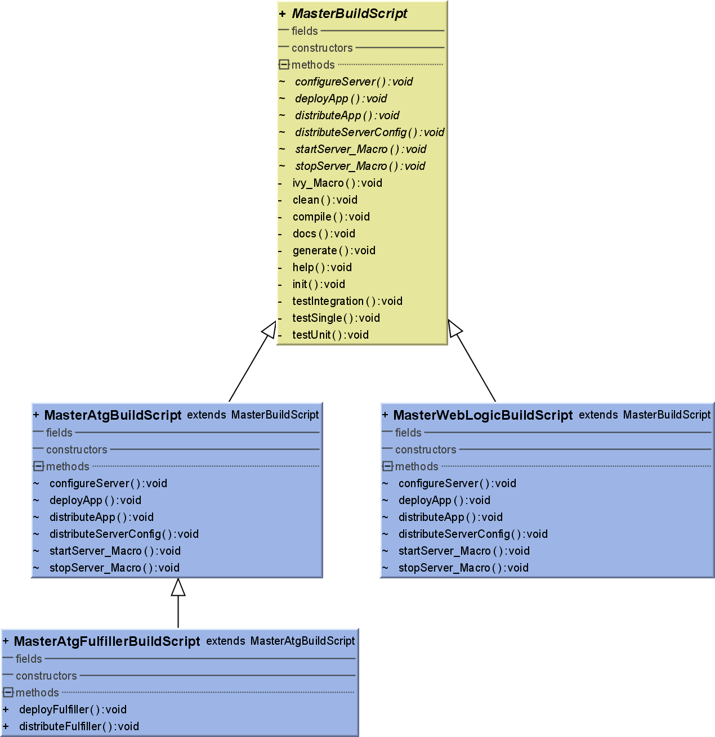
Figure 1 - Master Build Script Hierarchy

Advantages of Master/App scripts
To recap here are the advantages of structuring our builds this way:
- All application build scripts look the same
- New build scripts are trivial to create
- Potential for errors and bugs is greatly reduced
- Increased productivity
- More centralized control over build scripts and configuration

Resolved Issues
After a meeting with the tech leads, the following issues have been resolved:

Location of master build scripts – Master build script materials go into the JavaShared project (http://subversion/svn/javashared), in the master-build directory. Projects using this should create an external in the project root, pointing to the build dir. For example, your subversion external property would look like this:
build/master-build http://subversion.nike.com/svn/javashared/branches/OMR15_Dec-08/master-build

When development of the master build content is more mature, this will be a read-only tag instead of a branch.

Project directory structure – It was decided that all projects using the master build concept should have similar directory structures. This simplifies the build scripts greatly.

The structure is:

- Project root dir
  - build
    - master-build (external)
    - nike-ivy (external)
  - docs
  - source
    - configpath (ATG projects)
    - java
      - src
      - test
        - unit
        - integration
      - generated-source (BAPI-wrappers, etc – stuff that’s generated, but in source control)
    - scripts (PL/SQL, .sh files, etc.)
    - appname1.ear (the exploded EAR file, with WARs, etc)
    - appname2.ear, etc
  - unversioned (all files not in source control go here)
    - classes (where compiled classes go)
    - docs (generated docs – Javadocs, etc.)
    - gen-src (java files generated from WSDLs, JAX-B, etc.)
    - dist (distribution)
      - stage (where files are staged for either deployment or tarballing)
      - tar (where tarballs go)
    - weblogic
      - domain (weblogic domains)
    - lib (where Ivy puts library files)

Notice that all files not in source control go into “unversioned”. That means to get your project back into “as checked out” condition, just delete the “unversioned” directory.

Project Properties – The master build file needs properties, as does the project build file. My original idea was to have the build properties file (build.properties) have just the things needed for the project build.xml file, while the master-build.properties file would have what’s needed for the master-build.xml, etc.

The problem with this is that although Ant can resolve properties when they’re out of order in a single file, this doesn’t work across <property> invocations. For example, if build.properties is imported with
<property file="${basedir}/build/build.properties"/>
and contains the following lines
ivy.dep.file=${ivy.conf.dir}/nike-${app.name}.ivy.xml
ivy.conf.dir=${build.dir}
app.name=claims
src.dir=${base.dir}/src
jaxb.src.dir={src.dir}/jaxb

At run time, ivy.dep.file would resolve to build/nike-claims.ivy.xml, and jaxb.src.dir would resolve to src/jaxb.

However, if this information is split into two files, build.properties, which contains
app.name=claims
jaxb.src.dir={src.dir}/jaxb
and master-build.properties, which contains
ivy.dep.file=${ivy.conf.dir}/nike-${app.name}.ivy.xml
ivy.conf.dir=${build.dir}
src.dir=${base.dir}/src
and we import these with
<property file="${basedir}/build/build.properties"/>
<property file="${basedir}/build/master-build.properties"/>

When we run this, ivy.dep.file resolves to build/nike-${app.name}.ivy.xml, while jaxb.src.dir resolves to src/jaxb. Reversing the order of the imports
<property file="${basedir}/build/master-build.properties"/>
<property file="${basedir}/build/build.properties"/>
might solve the problem, but now ivy.dep.file resolves to build/nike-claims.ivy.xml, and jax.src.dir resolves to ${src.dir}/jaxb!

Bringing in properties from a properties file only allows property resolution within that file at import. That’s a limitation of Ant, and there’s no way around this.

The way to get around this is to use the build.cmd script to merge all the property files into one build.properties file – similar to the option above, but we do this in the build.cmd file instead of Ant.
  - Easy to do
  - Protects master configuration
  - Allows project-specific properties file

Another way to do this would be to write a custom Ant task to work like <property>, but allow it to bring in a series of property files, merge them together, and parse them at once. This is probably the more robust option, but does require a custom task that must be in the classpath, and expands the scope considerably. Also, the question of where to put the custom Ant task requires extra complexity as well.

Action Items/Open Issues
Make Subversion tags read-only - We really need to do this, and have been meaning to do it for quite a while. Not having tags read-only means that externals can be inadvertently edited in the sub projects (we’ve all done it!), and accidentally checked in.

Applicability to .NET projects
As NAnt is basically a clone of Ant, these concepts should also apply to NAnt scripts as well.

First Steps
- Create this document.
- Socialize it amongst the tech leads, get acceptance and buy-in.
- Implement the new build scripts in Claims and Returns as a pilot project

Related topics

Subversion External structure
Externals are very useful in Subversion, but a royal pain to track down if there’s more than one in a project. It makes sense to put all the externals in the top level of the project, where they can be easily found and edited (and copied across projects).

The DRPShared Project
One of the more frustrating things about working on ATG apps is the problem that part of the application configuration is stored in the application project directory, and part stored in the DRPShared project. There should be a better way to do this

Ideas to improve the DRPShared project:
- Streamline the builds – we’ve go so much cut/copy/paste in the DRPShared build file it’s hard to figure out what’s going on. Most of this
- Use Ivy to store all library files - Each DRP then has it’s own Ivy section, and separate lib/drp-X directory for the resulting resources
- Streamline the DOS and shell scripts to use whatever libs are in the directories. This will get around the developer having to remember to update the scripts every time a library is added.
- Set up Subversion externals in the ATG projects, so that a project using DRP-6 would have access to that DRP’s configuration?
- Move to WebLogic ☺

Überbuild script
It’d be convenient for the build master to have an “überbuild” script – a build script above all related build scripts. This is particularly important for Atlas and OC builds, in which many components of an application must be built, some in a specified order.

The “überbuild” script is basically a build script which calls other build scripts in sequence, so the build master only needs to kick off a single build target, which in turn automatically calls all needed builds. This can be accomplished by use of the <subant> task.

